2024 UNESCO ICM Martial Arts Education Prize Social Media Kit

With the purposes of collecting and supporting martial arts education good practices worldwide, ICM has been operating the UNESCO ICM Martial Arts Education Prize since 2021. For 2024, ICM has opened calls from March 20th until May 20th (24:00, Korean Standard Time). Please find below social media kits which include two images and texts.

- Images
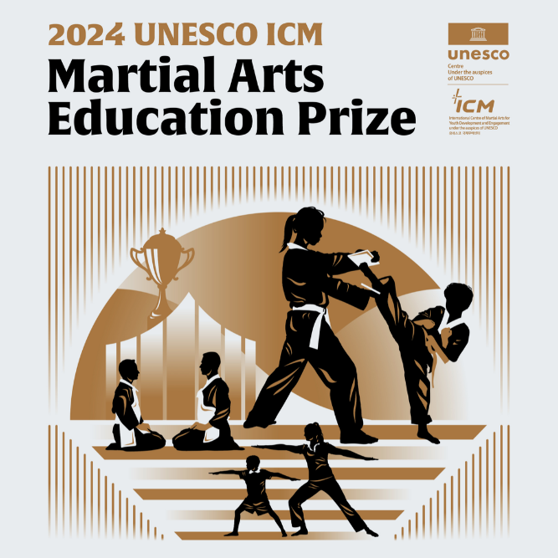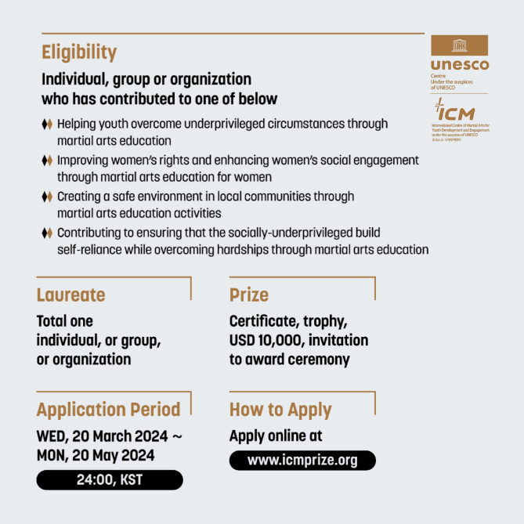

- Text
The International Centre of Martial Arts for Youth Development and Engagement under the auspices of UNESCO (ICM) has opened calls for the 2024 UNESCO ICM Martial Arts Education Prize. The winner will be awarded 10,000 USD and more. Application is open from 20 March to 20 May, 2024 (Korea Standard Time). Any individual, group or organization that has contributed in social development including youth and women empowerment, etc. may apply for the prize online (www.icmprize.org).

- Recommended Hashtags
@unescoicm #martialarts #martialartseducation #sportfordevelopment #unescoprizes

